- As a user, I want to change my password and/or full name.  
- As an admin, I want to add a new user into the system.  
- As an admin, I want to update the type/class of a user into the system (e.g., from cashier to manager).  
- As a manager, I want to add a new product or update a current product in the system.  
- As a manager, I want to view a summary report of sales from the system.  
- As a cashier, I want to add a new customer or update a current customer in the system.  
- As a cashier, I want to add a new purchase or update a current purchase (only price and quantity) in the system.  
- As a customer, I want to add a new purchase into the system.  
- As a customer, I want to view my purchase history into the system.  
- As a customer, I want to search for product information (based on name, price) in the system.

Tasks:

1. Rewrite a common use cases for each user story. Sketch the screens the system should display in each use case.

1. user

- As a user, I want to change my password and/or full name.

A. Name: changing password and/or full name

B. Actors: user

C. Goals: change my password and/or full name

D. Steps:

1. login

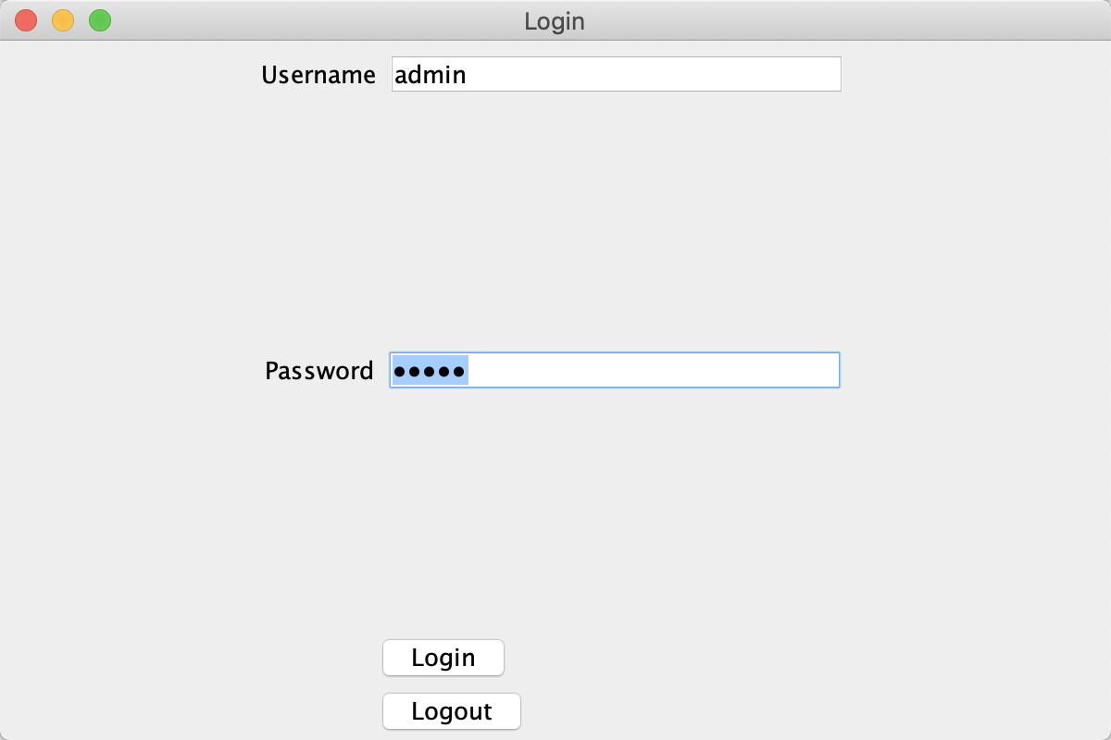

2. main page

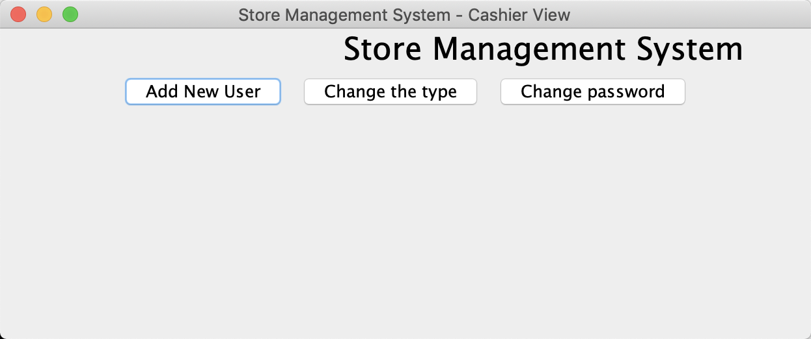

3. change password

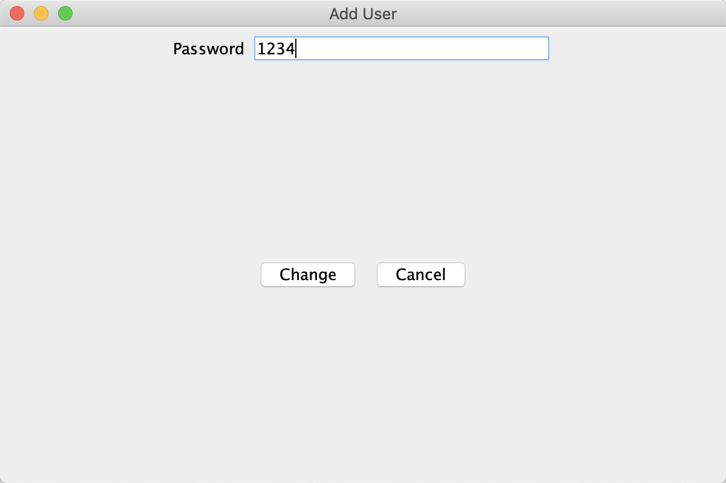

4. change successfully

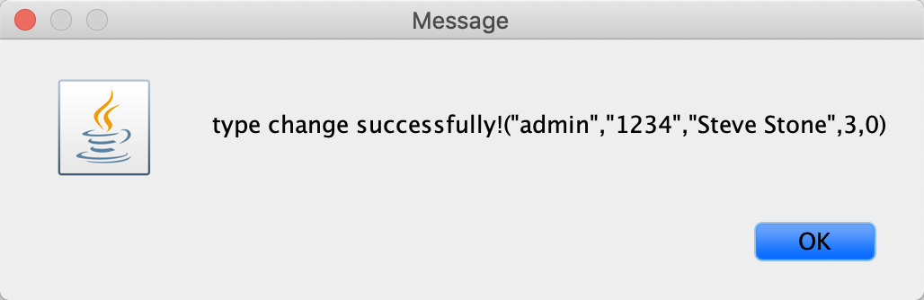

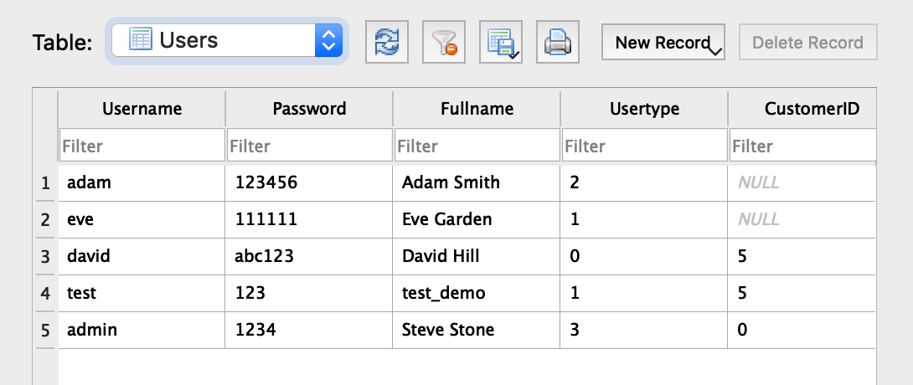

2. Admin

a). - As an admin, I want to add a new user into the system.

A. Name: Adding a new user into the system

B. Actors: admin

C. Goals: to add a new user into the system

D. Steps:

1. admin login

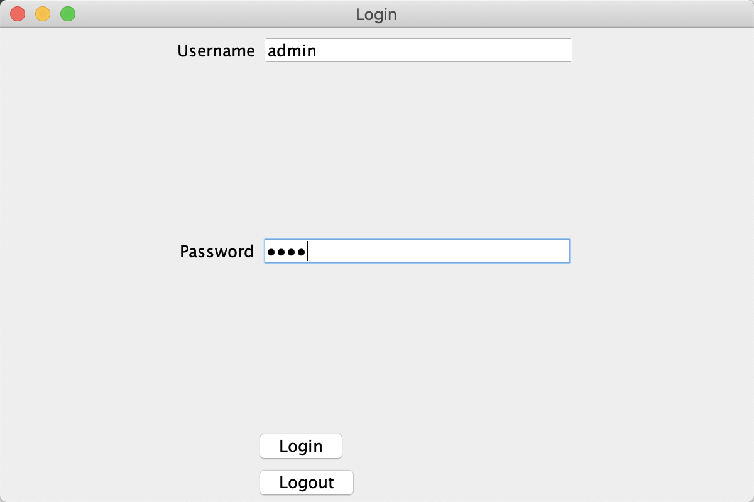

2. click ‘login’ button to enter into the admin main page

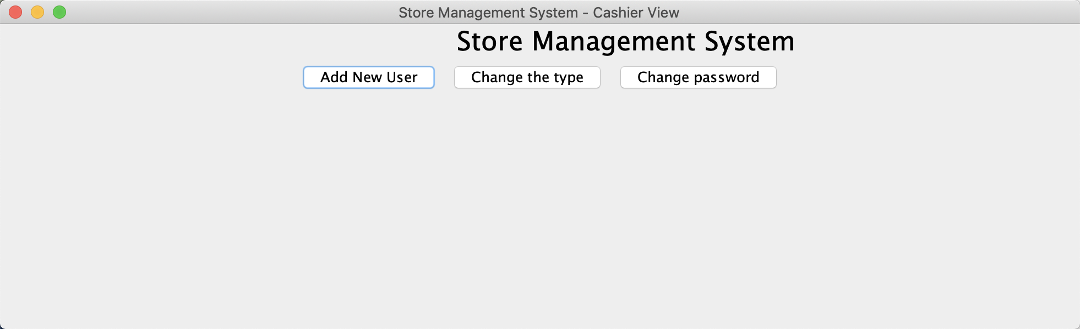

3. click ‘add new user’ button to enter into the add new user page, and then enter into the information of the customers to add new customer.

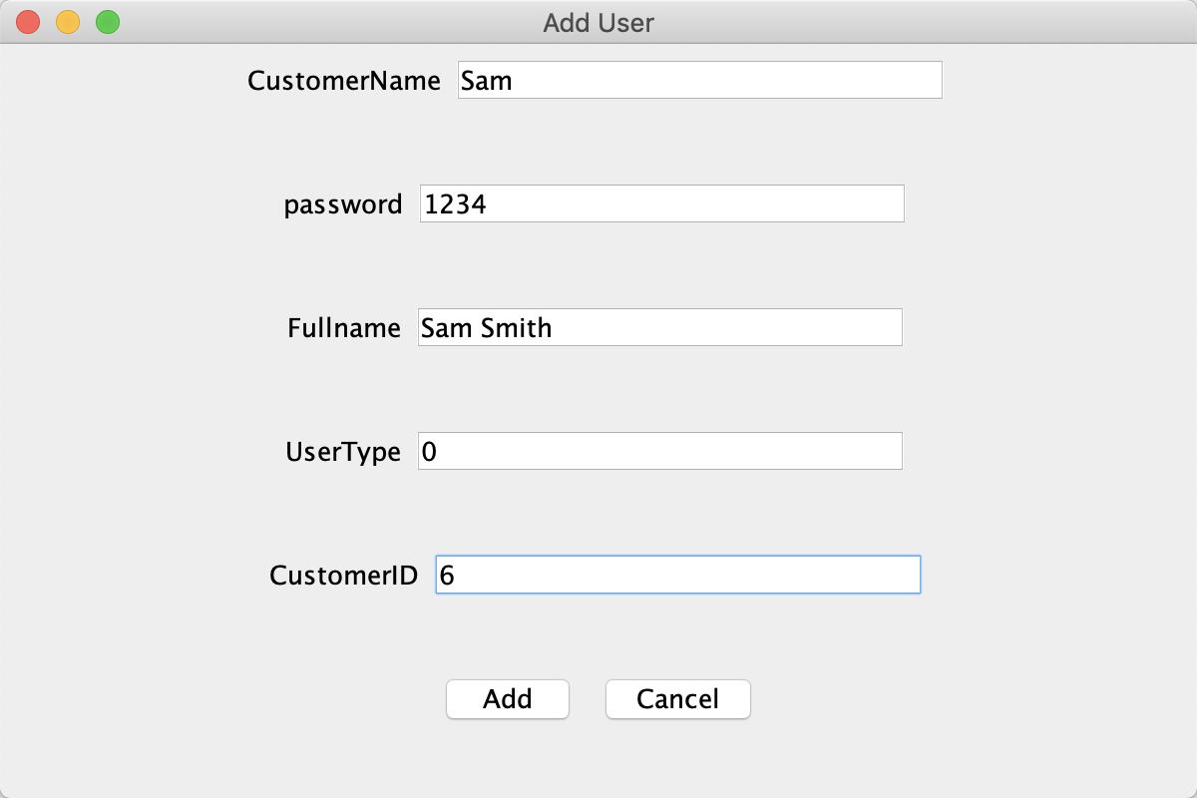

4. add successfully

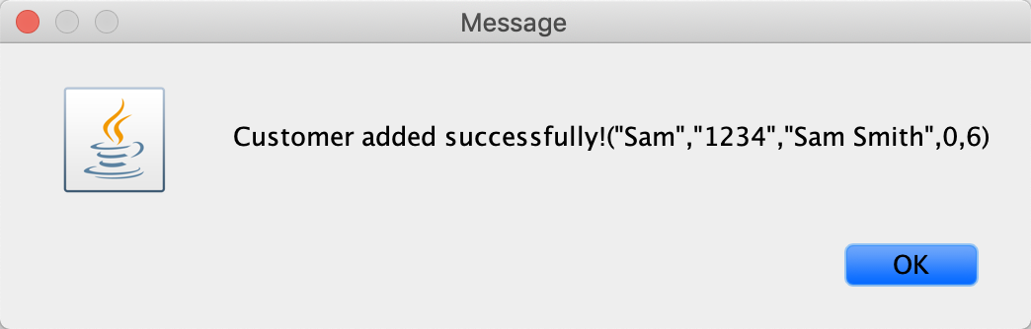

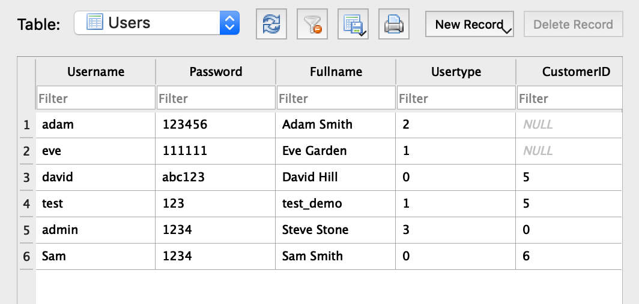

b). As an admin, I want to update the type/class of a user into the system (e.g., from cashier to manager).

A. Name: updating the type/class of a user into the system

B. Actors: admin

C. Goals: to update the type/class of a user into the system

D. Steps:

1. admin login



2. enter into the admin main page

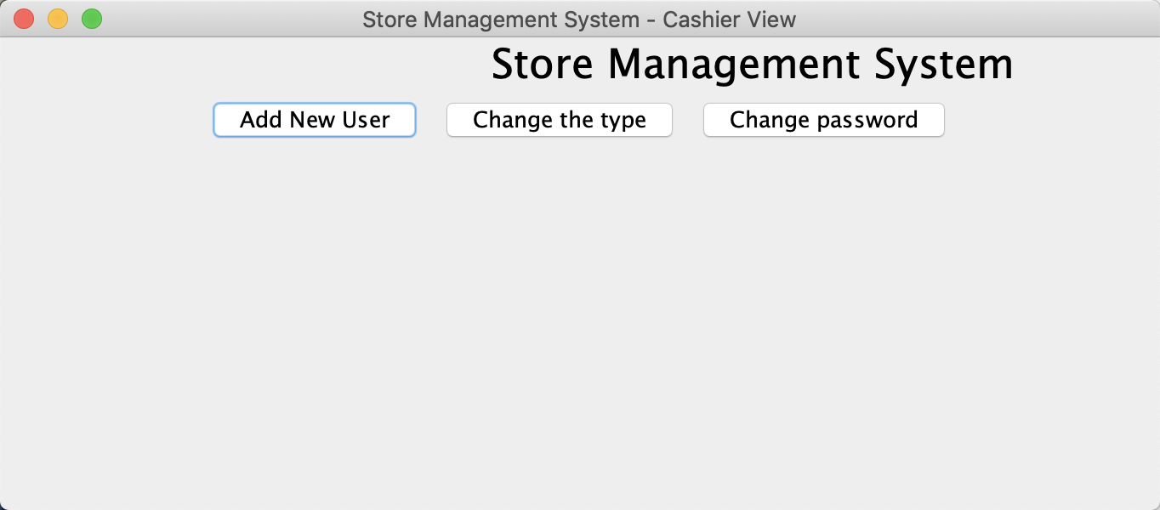

3. click ‘change the type’ button to enter into the change page

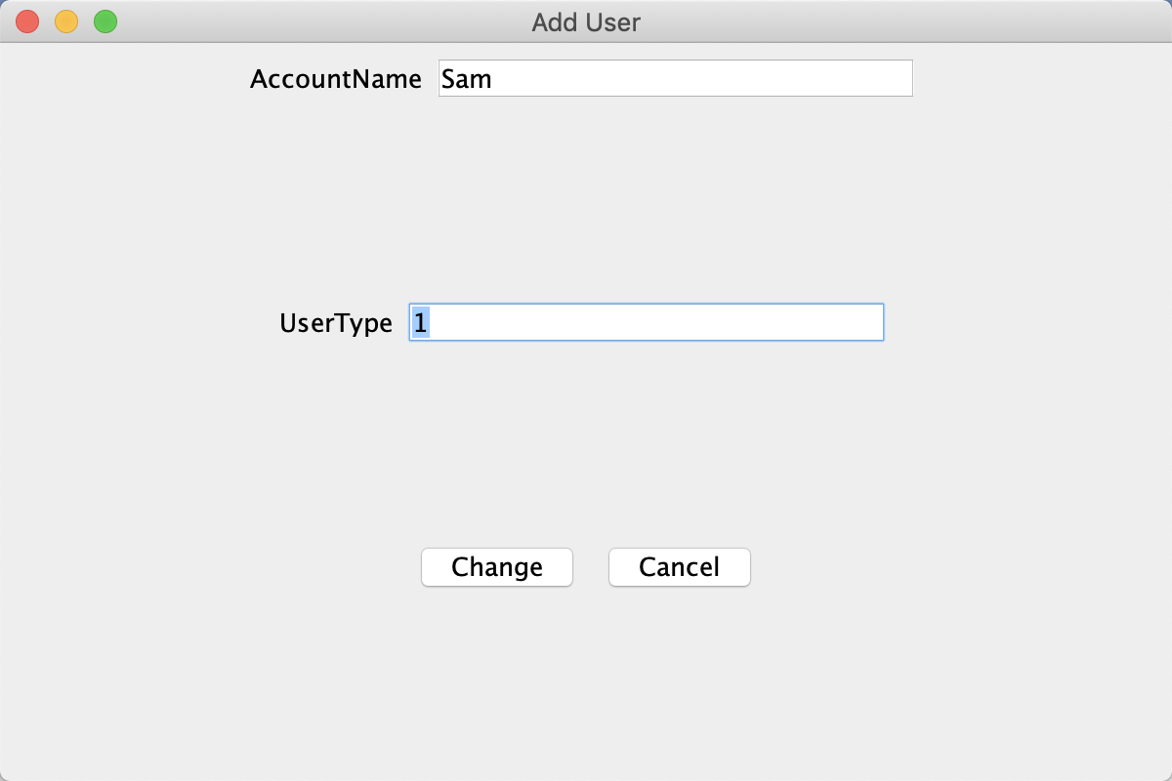

4. change successfully

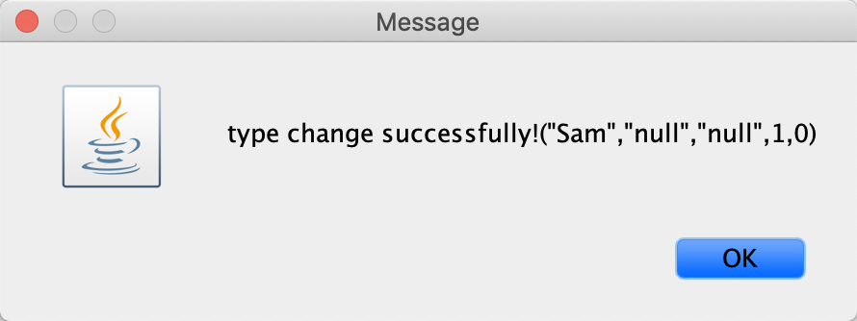



3. Manager

a). - As a manager, I want to add a new product or update a current product in the system.

A. Name: Adding a new product or update a current product in the system.

B. Actors: manager

C. Goals: to add a new product or update a current product in the system

D. Steps:

1. type in the manager’s account to login

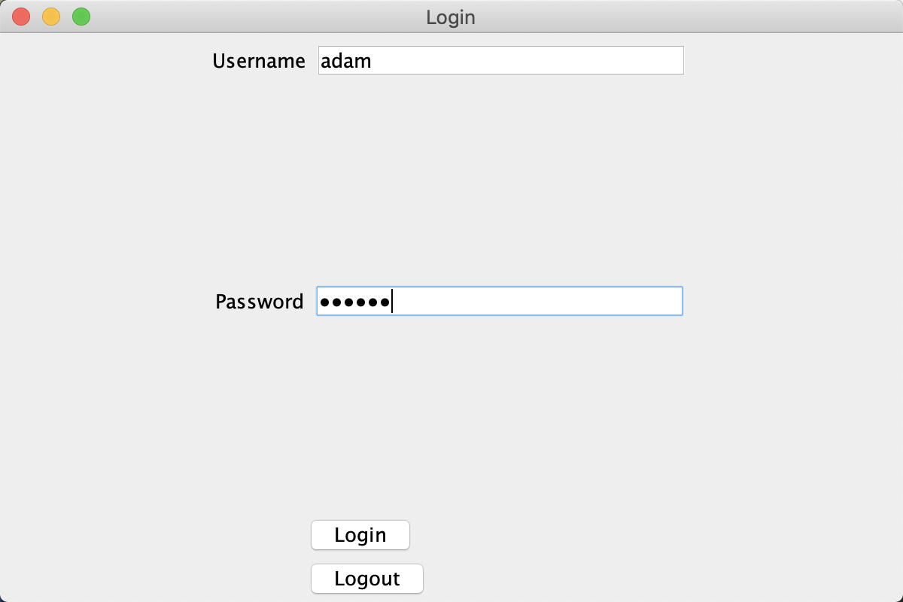

2. enter into the manager main page

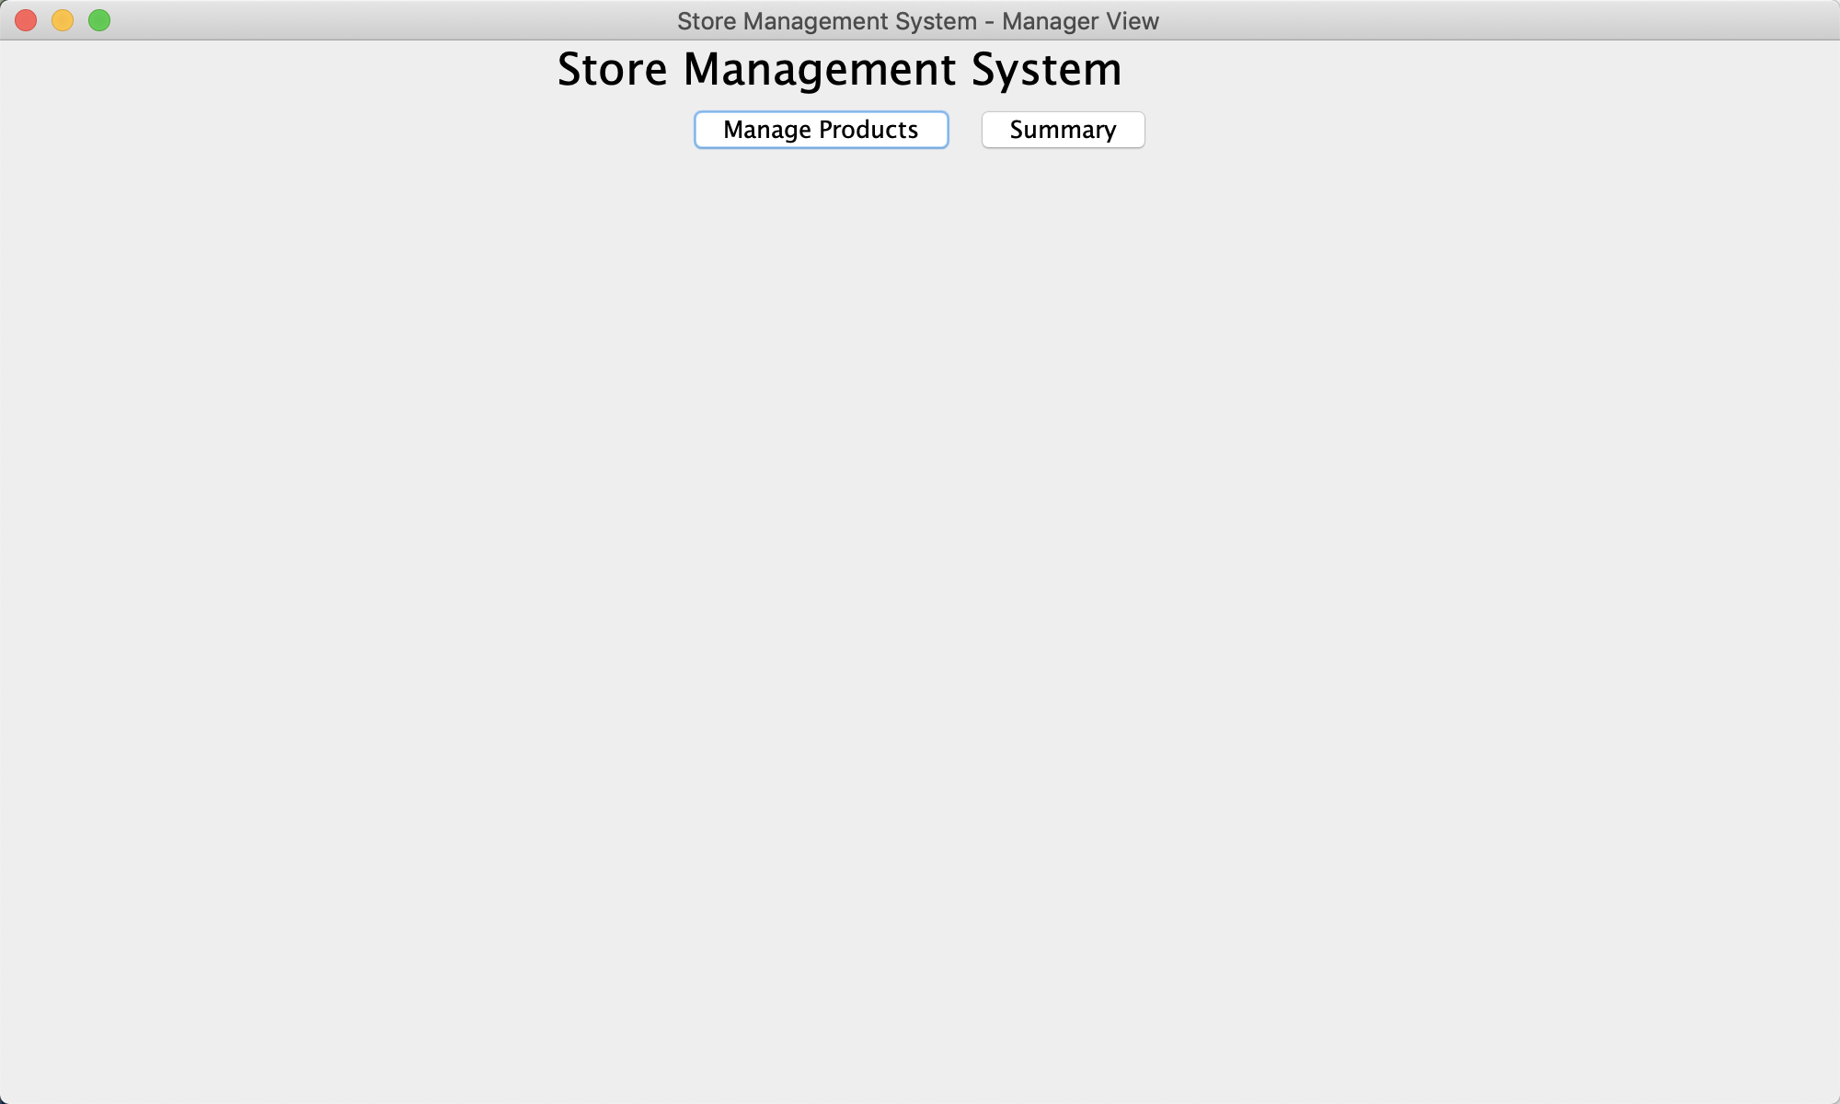

3. click on the ‘manage products’ button to enter into the management page

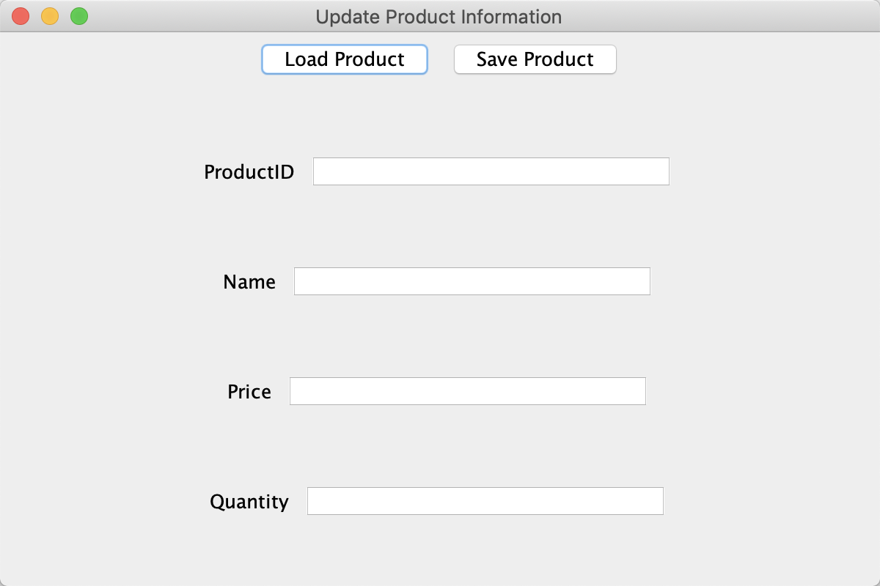

4. type in the information of a new product to add a new product

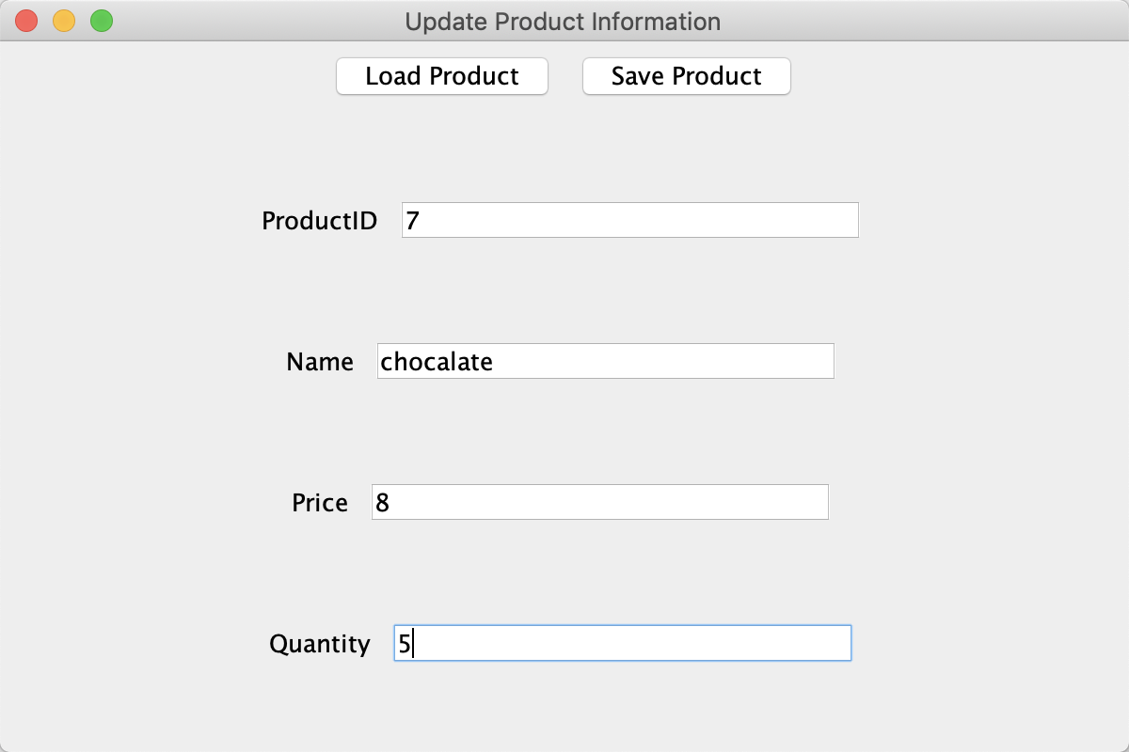

8. click on the save button to add

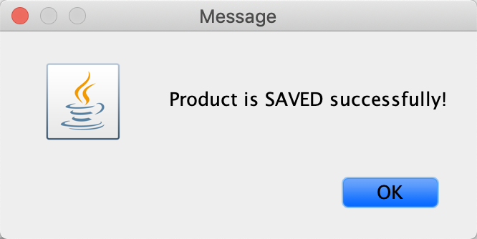

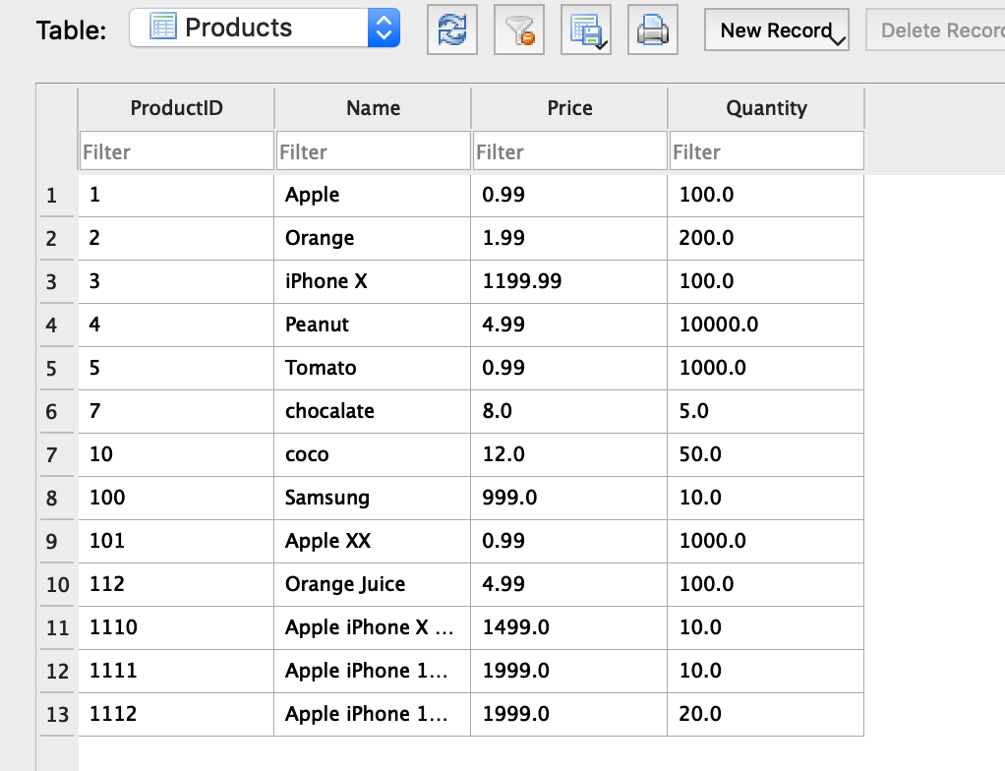

9. type in the productid to load the product

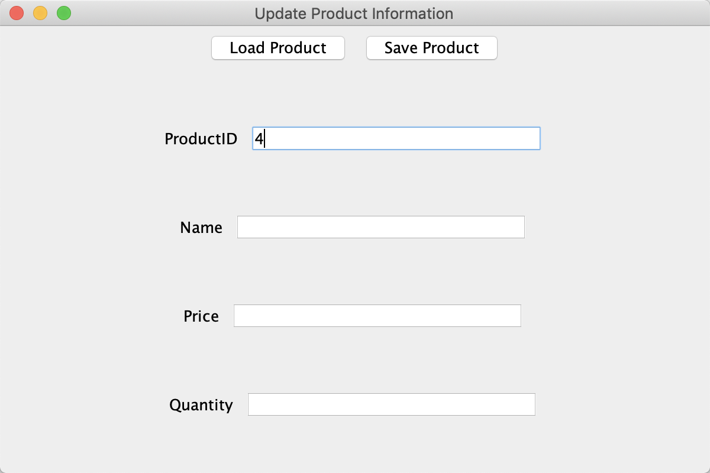

10. click on the load button to load the information of the product

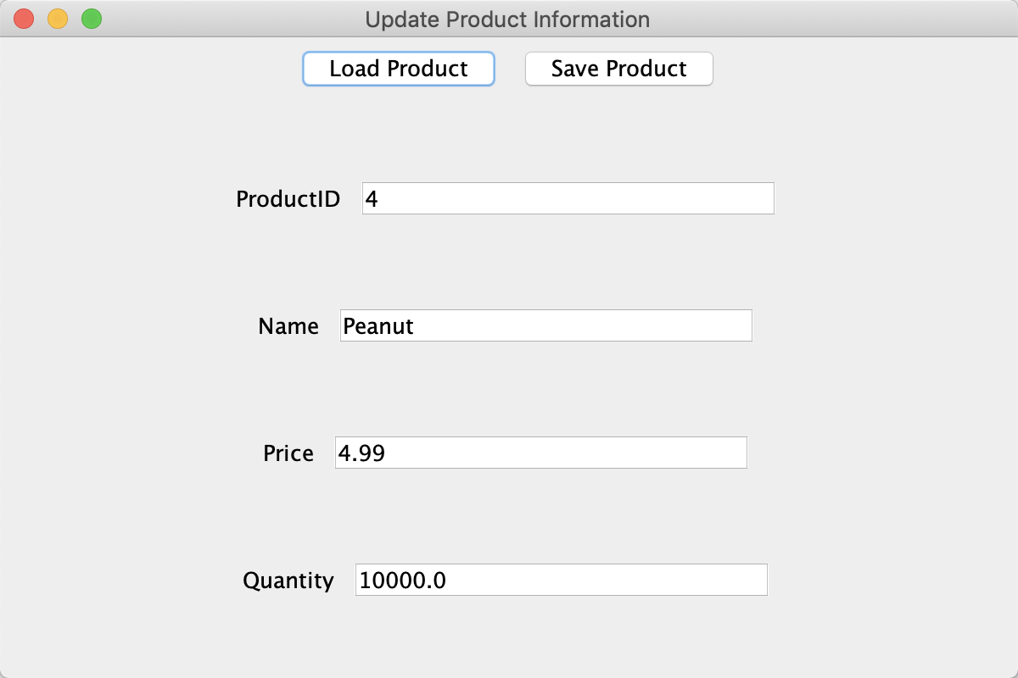

11. change the information of the product

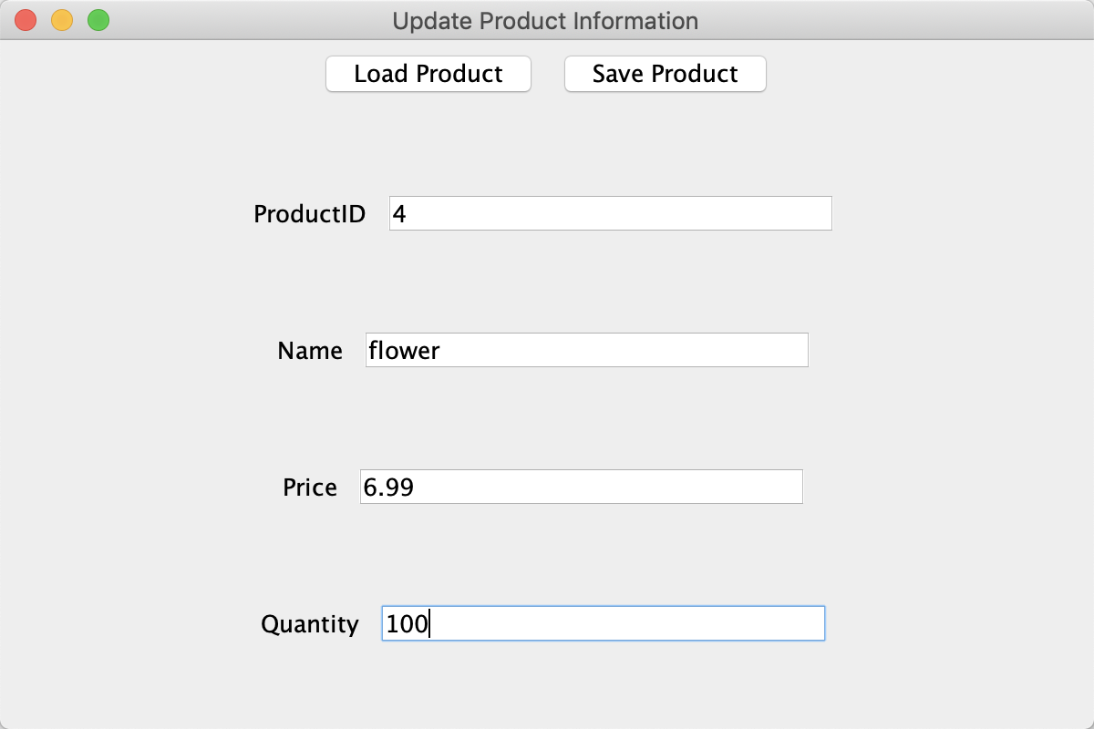

12. click the save button to update successfully

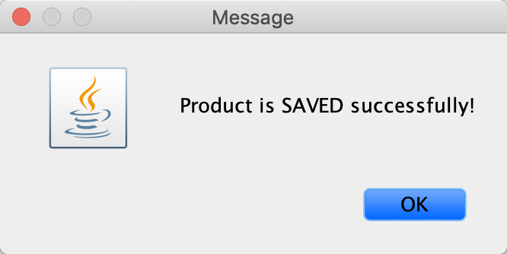

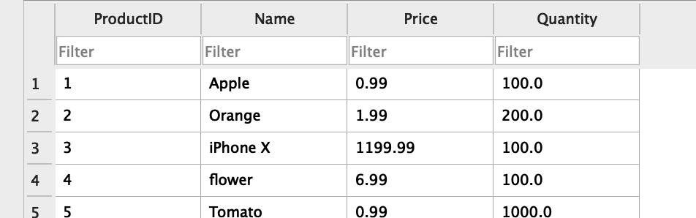

b). - As a manager, I want to view a summary report of sales from the system.

A. Name: view a summary report of sales from the system

B. Actors: manager

C. Goals: to view a summary report of sales from the system

D. Steps:

1. type in the manager’s account to login



2. enter into the manager main page



3. click on the ‘summary’ button to see the report

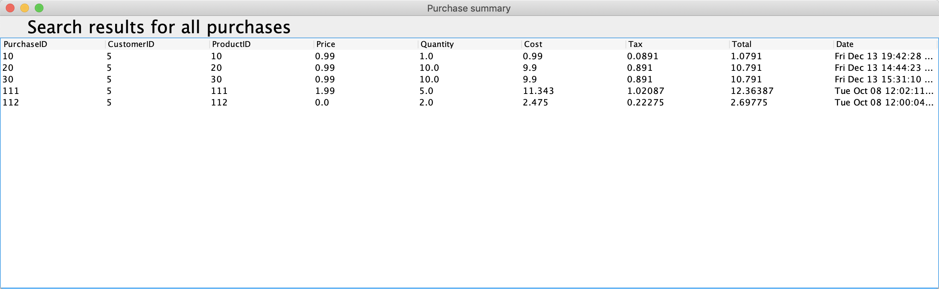

4. Cashier

a). -As a cashier, I want to add a new customer.

A. Name: Adding a new customer in the system

B. Actors: cashier

C. Goals: to add a new customer in the system

D. Steps:

1. type in the cashier account to login

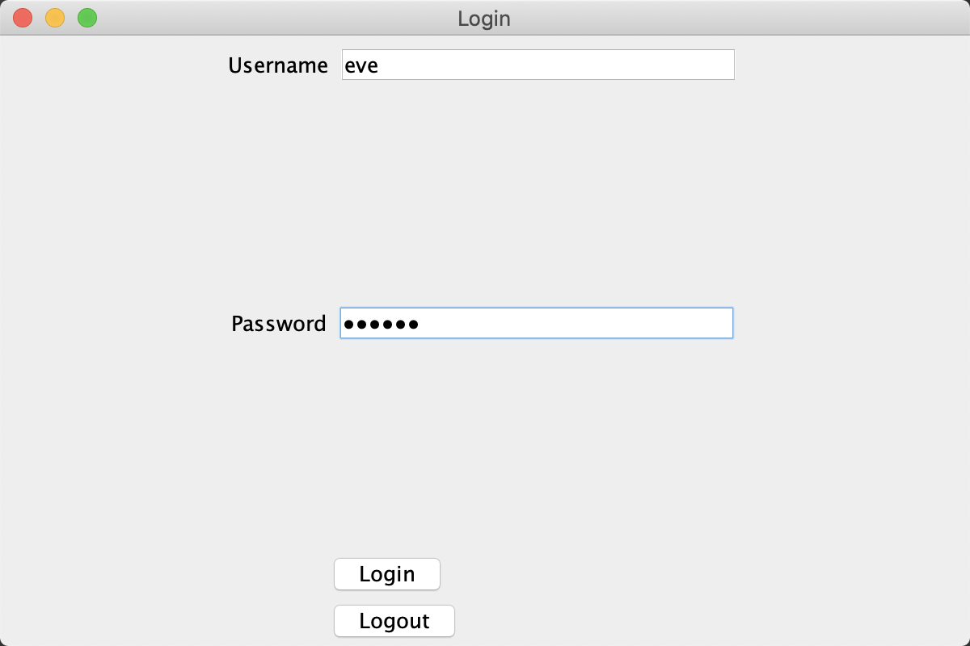

2. enter into the management page

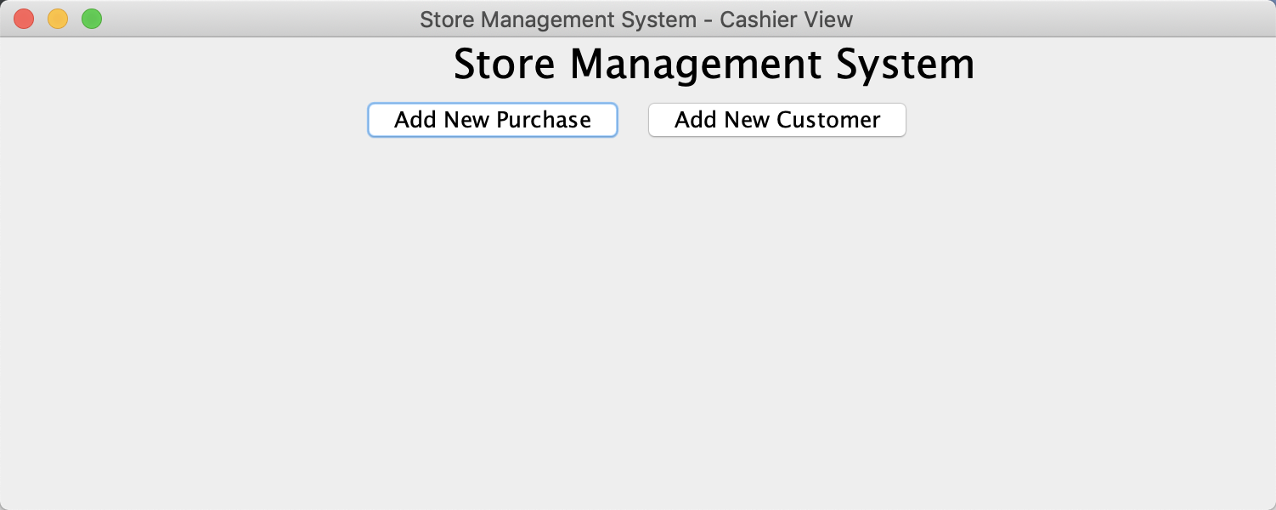

3. click on the ‘add new customer’ button

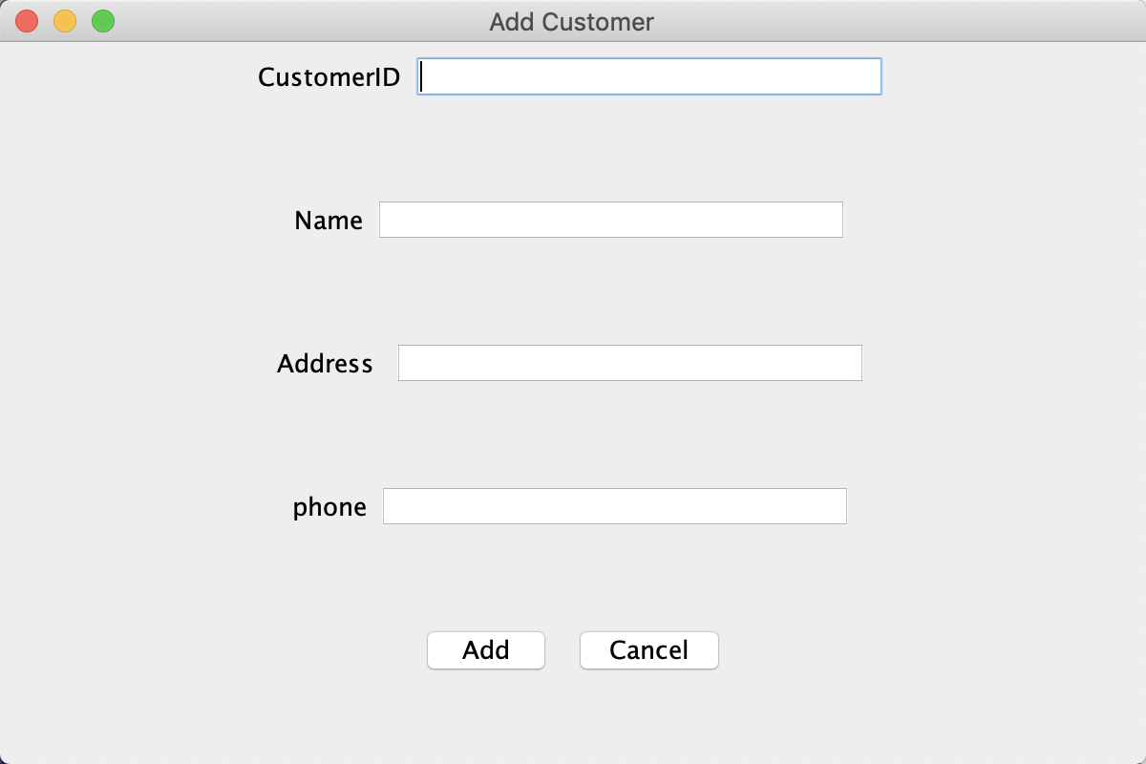

4. type in the information of the new customer

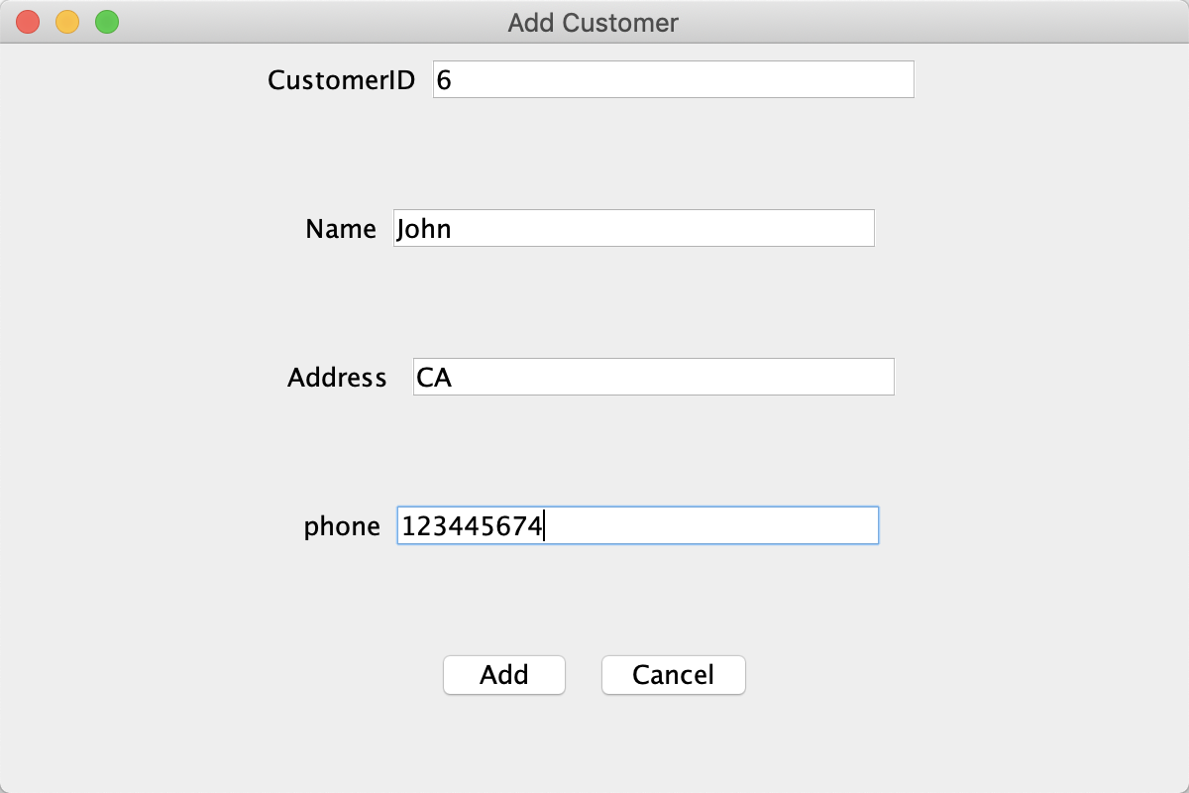

5. click on the ‘add’ button

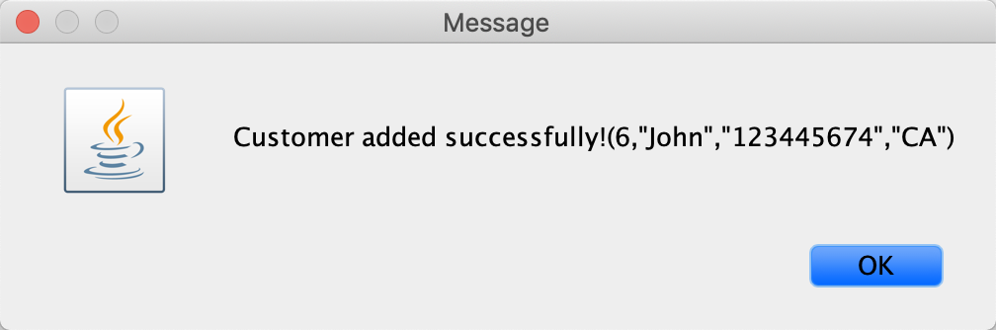

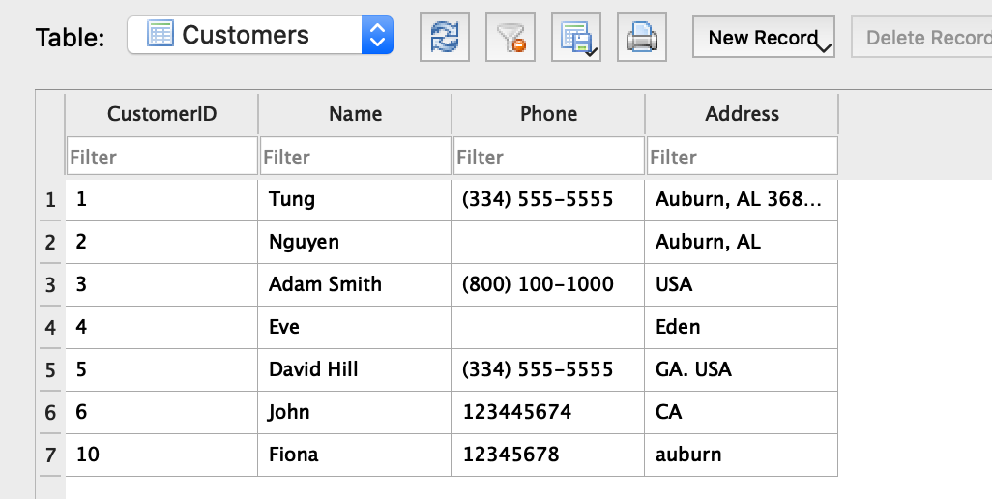

b). - As a cashier, I want to add a new purchase in the system.

A. Name: adding a new purchase in the system

B. Actors: cashier

C. Goals: to add a new purchase in the system

D. Steps:

1. type in the cashier account to login



2. enter into the management page



3. click on the ‘add new purchase’ button

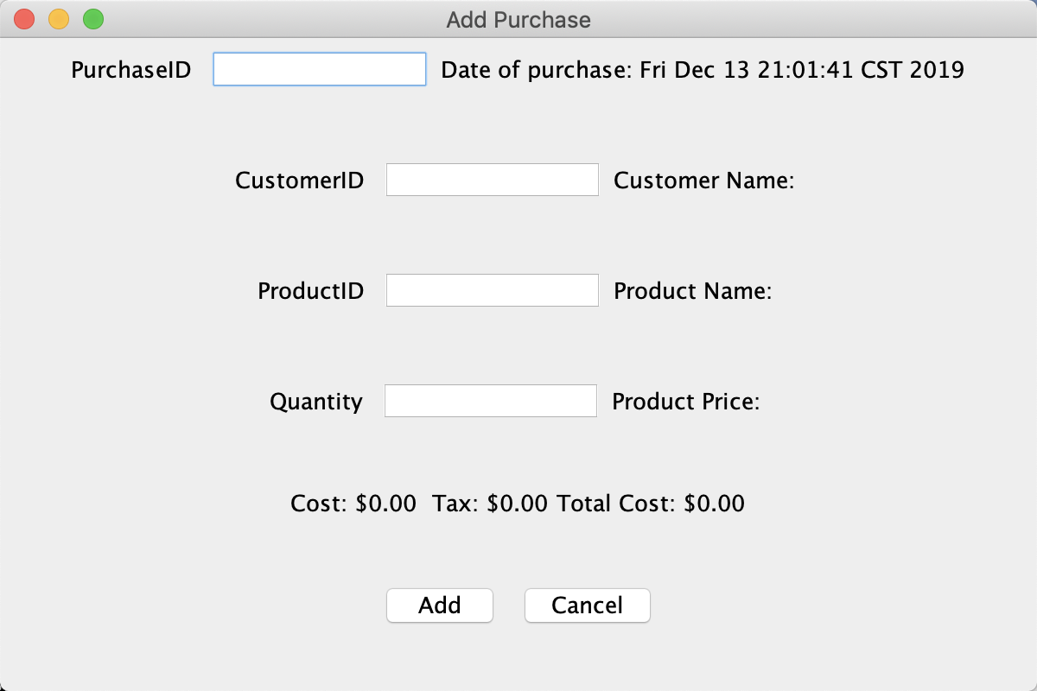

4. type in the information of the purchase

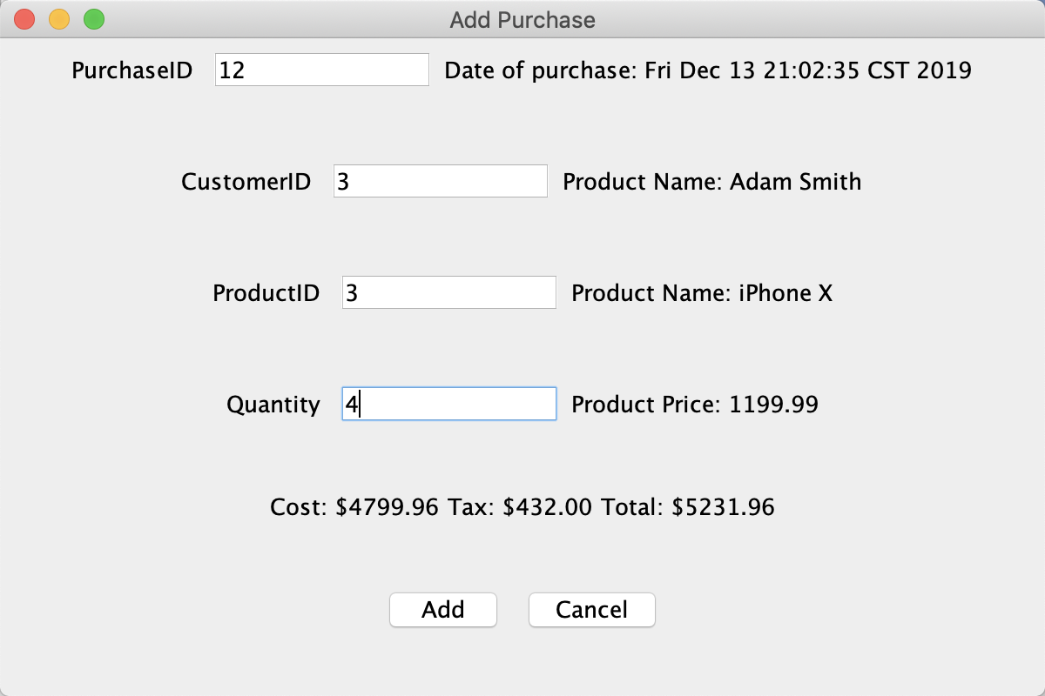

5. click on ‘add’ button

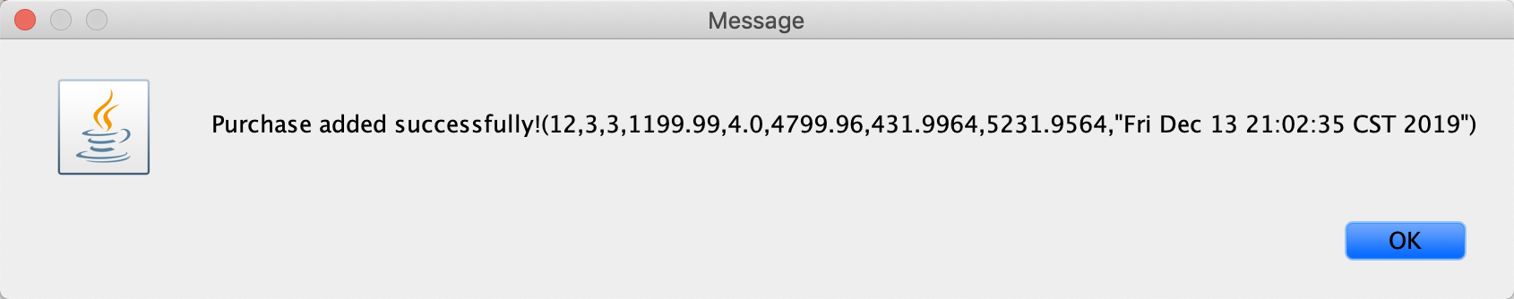

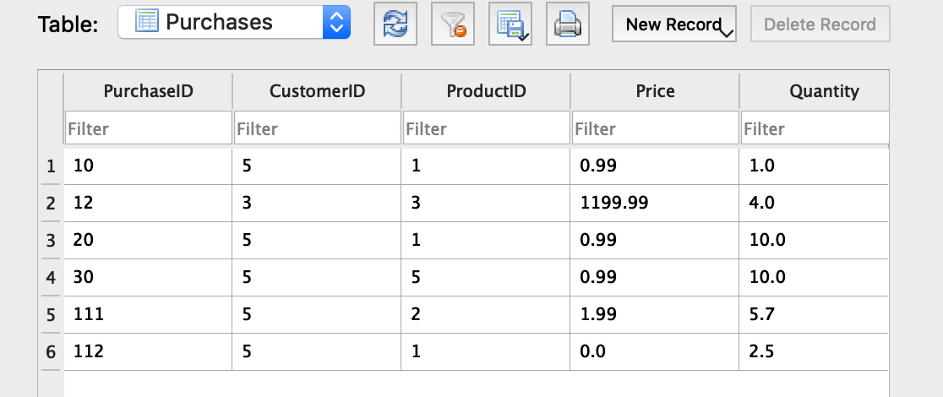

5. Customer

a). - As a customer, I want to add a new purchase into the system.

A. Name: Adding a new purchase into the system

B. Actors: customer

C. Goals: to add a new purchase into the system

D. Steps:

1. type in the customer account to log in

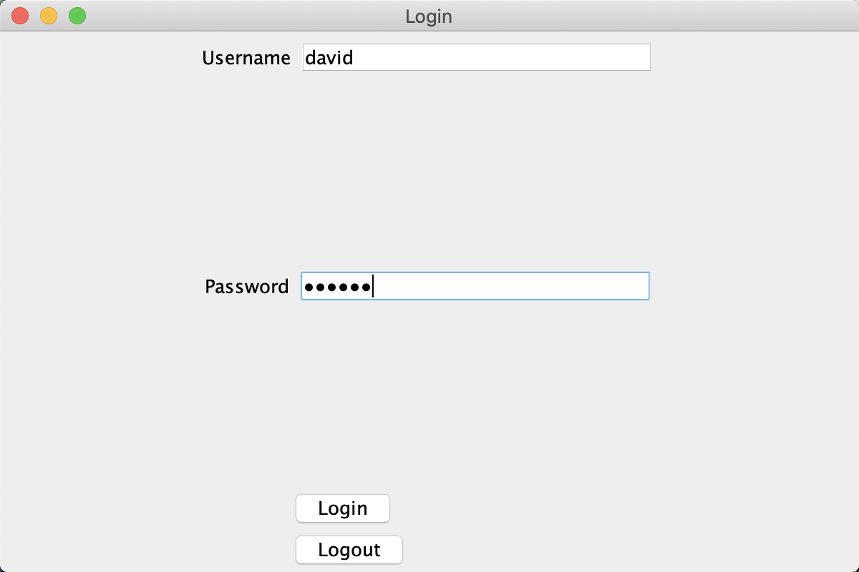

2. enter into the management page

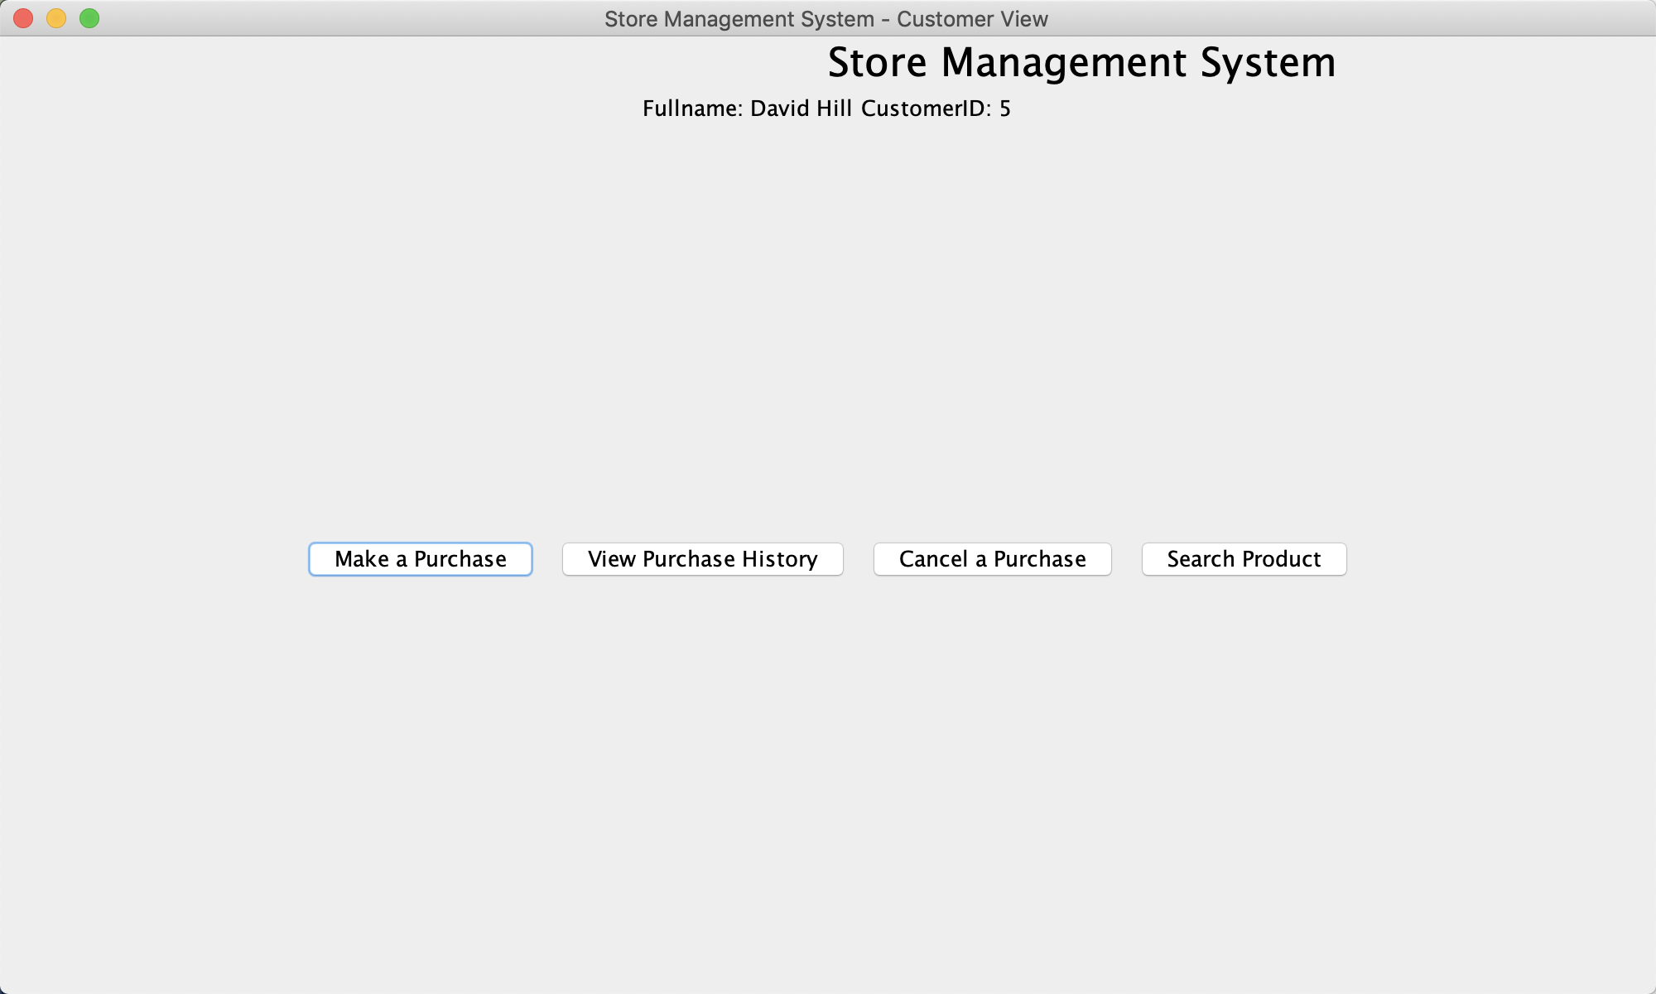

3. click on ‘make a purchase’ button to add a new purchase

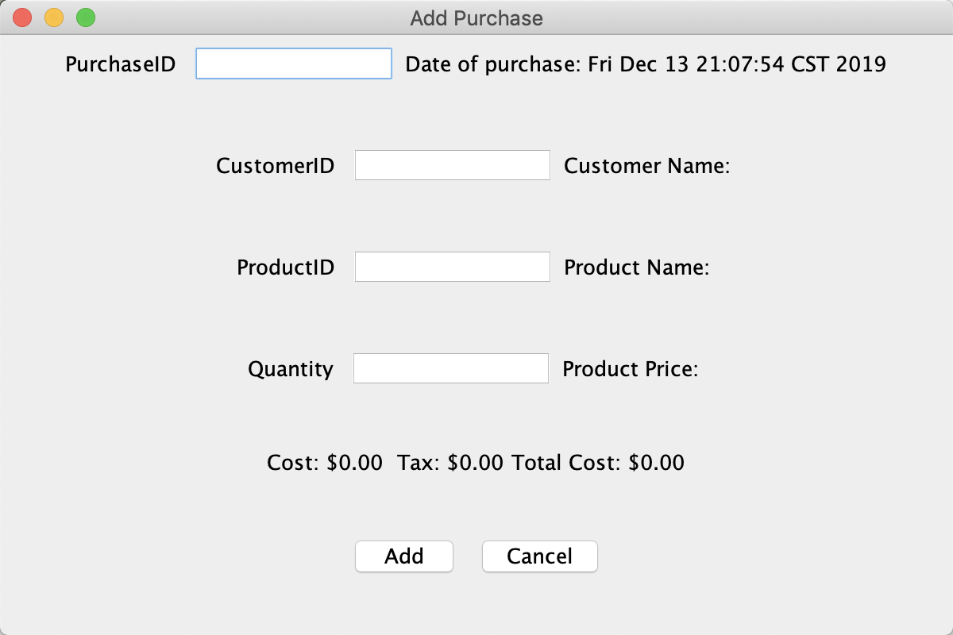

4. type in the information of the purchase

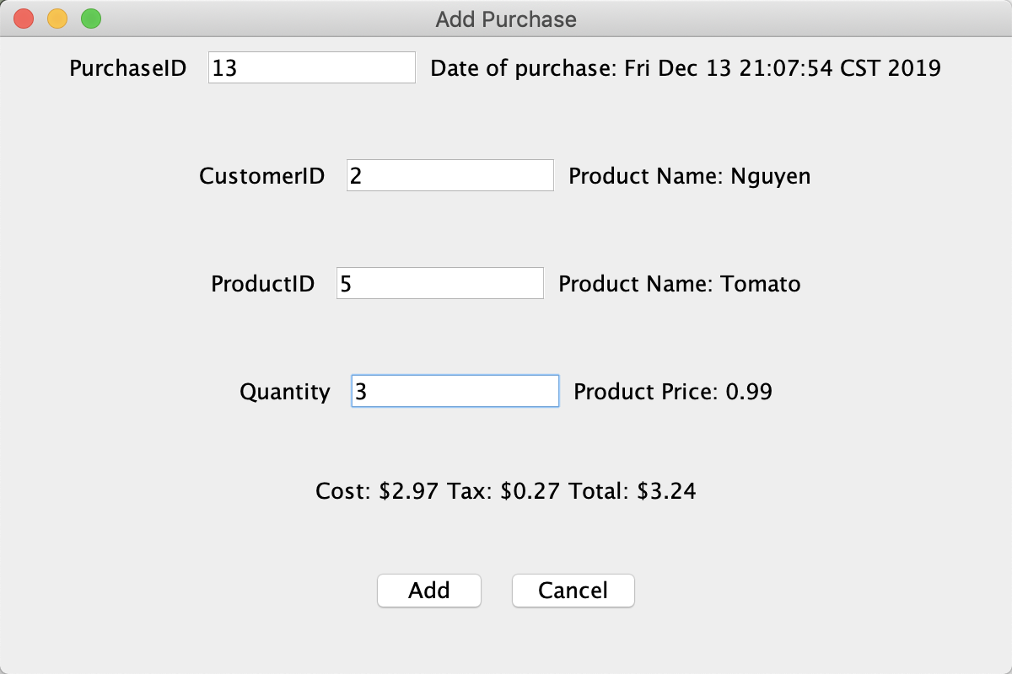

5. click on ‘add’ button



6. add successfully

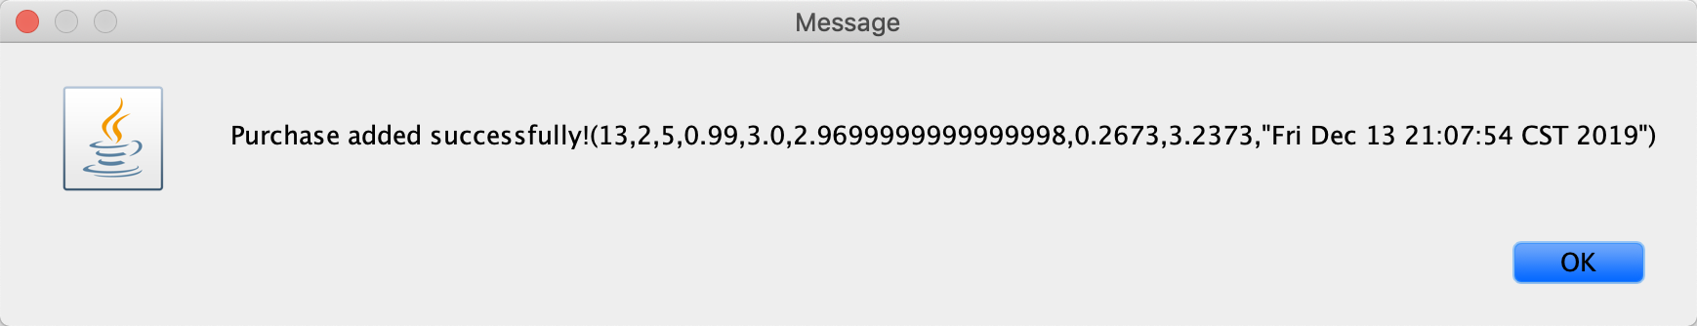

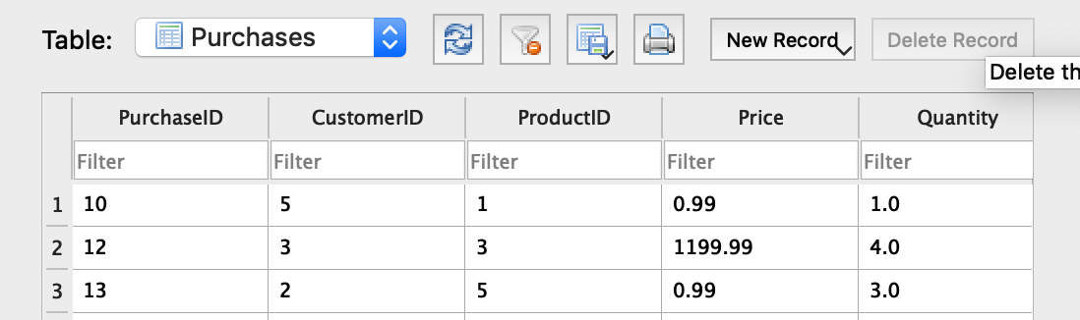

b). - As a customer, I want to view my purchase history into the system.

A. Name: viewing my purchase history into the system

B. Actors: customer

C. Goals: to view my purchase history into the system

D. Steps:

1. type in the customer account to log in



2. enter into the management page



3. click on the ‘view purchase history’ button to view purchase history

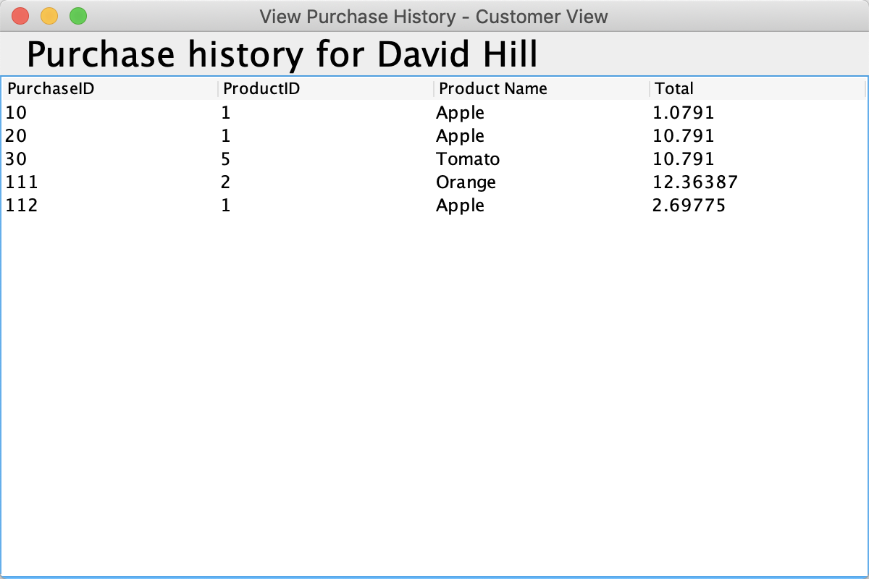

c). - As a customer, I want to search for product information (based on name, price) in the system.

A. Name: searching for product information (based on name, price) in the system

B. Actors: customer

C. Goals: to search for product information (based on name, price) in the system

D. Steps:

1. type in the customer account to log in



2. enter into the management page



3. click on the ‘search product’ button to search the product

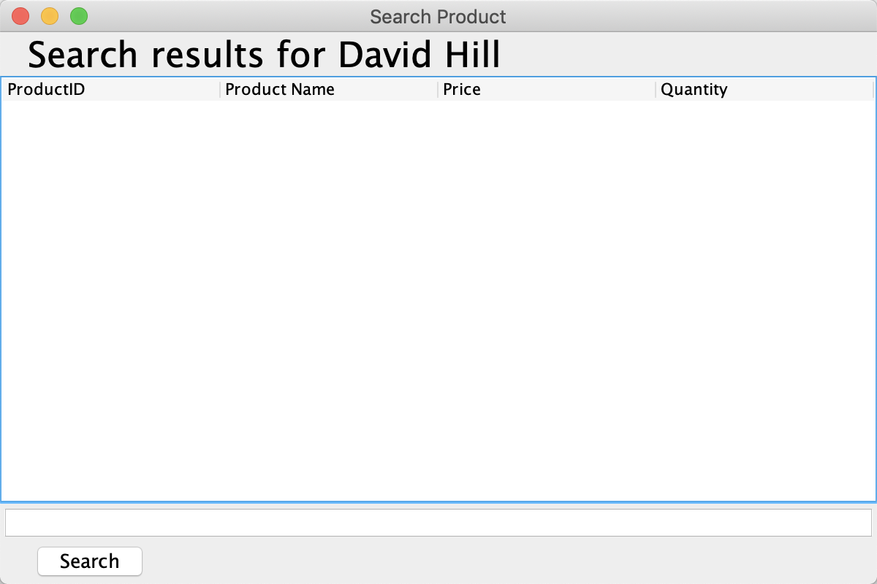

4. type in the information of the product to search the product

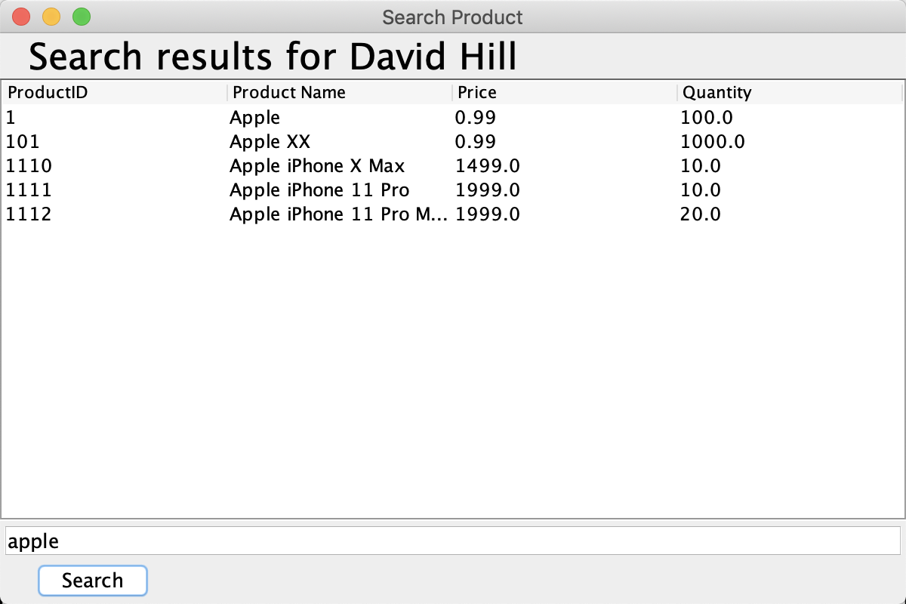

SQL code

﻿CREATE TABLE "Customers" (

"CustomerID" INTEGER NOT NULL,

"Name" TEXT DEFAULT 'Guest',

"Phone" TEXT DEFAULT '(334) 555-5555',

"Address" TEXT,

PRIMARY KEY("CustomerID")

)

﻿CREATE TABLE "Products" (

"ProductID" INTEGER NOT NULL,

"Name" TEXT,

"Price" REAL,

"Quantity" REAL,

PRIMARY KEY("ProductID")

)

﻿CREATE TABLE "Purchases" (

"PurchaseID" INTEGER NOT NULL,

"CustomerID" INTEGER NOT NULL,

"ProductID" INTEGER NOT NULL,

"Price" REAL NOT NULL,

"Quantity" REAL NOT NULL,

"Cost" REAL NOT NULL,

"Tax" REAL NOT NULL,

"Total" REAL NOT NULL,

"Date" TEXT NOT NULL,

PRIMARY KEY("PurchaseID")

)

﻿CREATE TABLE "Users" (

"Username" TEXT NOT NULL UNIQUE,

"Password" TEXT NOT NULL,

"Fullname" TEXT,

"Usertype" INTEGER,

"CustomerID" INTEGER,

PRIMARY KEY("Username")

)